5.1 - Create a multimodal analysis solution with Azure AI Content Understanding
What is Azure AI Content Understanding?
Azure AI Content Understanding is a generative AI service that you can use to extract insights and data from multiple kinds of content. With Content Understanding, you can quickly build applications that analyze complex data and generate outputs that can be used to automate and optimize processes.
Content Understanding is a component of Azure AI services. To use it, you need to provision an Azure AI services resource in your Azure subscription. You can develop and manage a Content Understanding solution:
- In the Azure AI Foundry portal
- By using the Content Understanding REST API
Multimodal content analysis
Content Understanding can extract information from common kinds of content, enabling you to use a single service with a straightforward and consistent development process to build multimodal content analysis solutions.
- Documents and forms
  - You can use Content Understanding to analyze documents and forms and retrieve specific field values. For example, you could extract key data values from an invoice to automate payment processing.
- Images
  - You can analyze images to infer information from visuals such as charts, identify physical defects in products or other items, detect the presence of specific objects or people, or determine other information visually.
- Audio
  - Analysis of audio enables you to automate tasks like summarizing conference calls, determining sentiment of recorded customer conversations, or extracting key data from telephone messages.
- Video
  - Video accounts for a large volume of the data captured today, and you can use Content Understanding to analyze and extract insights from video to support many scenarios. For example, to extract key points from video conference recordings, to summarize presentations, or to detect the presence of specific activity in security footage.

Create a Content Understanding analyzer
Content Understanding solutions are based on the creation of an analyzer; which is trained to extract specific information from a particular type of content based on a schema that you define.
The high-level process for creating a Content Understanding solution includes the following steps:
- Create an Azure AI services resource.
- Define a Content Understanding schema for the information to be extracted. This can be based on a content sample and an analyzer template.
- Build an analyzer based on the completed schema.
- Use the analyzer to extract or generate fields from new content.
Creating an analyzer with Azure AI Foundry
- Creating a Content Understanding project
  - In Azure AI Foundry, you can create a project in an existing AI hub, or you can create a new hub as you create the project. In addition to the AI hub itself, creating a hub provisions the Azure resources needed to support one or more projects; including an Azure AI services resource, storage, and a key vault resource to store sensitive details like credentials and keys.
- Defining a schema
  - After creating a project, the first step in building an analyzer is to define a schema for the content the analyzer will process, and the information it will extract. Azure AI Foundry provides a schema editor interface in which you can upload a file (document, image, audio, or video) on which the schema should be based. You can then apply an appropriate schema template and define the specific fields you want the analyzer to identify.
- Testing
  - You can test the analyzer schema at any time during the development process by running analysis on the sample file used to define the schema or other uploaded files. The test results include the extracted field values and the JSON format output returned by the analyzer to client applications.
- Building an analyzer
  - When you're satisfied with the performance of your schema, you can build your analyzer. Building an analyzer makes it accessible to client applications through Content Understanding endpoint for the Azure AI services resource associated with your project.
Use the Content Understanding REST API
- The Content Understanding REST API provides a programmatic interface that you can use to create, manage, and consume analyzers.
- To use the REST API, your client application submits HTTP calls to the Content Understanding endpoint for your Azure AI services resource, passing one of the authorization keys in the header. You can obtain the endpoint and keys in the Azure portal or in the Azure AI Foundry portal. You can also use the Azure AI Foundry API to connect to the project and retrieve the endpoint and key for your Azure AI Services resource programmatically.

Using the REST API to analyze content
One of the most common uses of the REST API is to submit content to an existing analyzer that you have previously built, and retrieve the results of analysis. The analysis request returns an operation ID value that represents an asynchronous task. Your client application must then use another request to pass the operation ID back to the endpoint and retrieve the operation status - potentially polling multiple times until the operation is complete and the results are returned in JSON format.

5.2 - Create an Azure AI Content Understanding client application
Azure AI Content Understanding is a multimodal service that simplifies the creation of AI-powered analyzers that can extract information from multiple content formats, including documents, images, audio files, and videos.

Prepare to use the AI Content Understanding REST API
Before you can use the Azure AI Content Understanding REST API, you need an Azure AI services multi-services resource in your Azure subscription. You can provision this resource in the following ways:
- Create an Azure AI services resource in the Azure portal.
- Create an Azure AI Foundry hub, which includes an Azure AI services resource by default.

After you've provisioned an Azure AI services resource, you need the following information to connect to the Azure AI Content Understanding REST API from a client application:
- The Azure AI services resource endpoint
- One of the API keys associated with the endpoint.

Create a Content Understanding analyzer
In most scenarios, you should consider creating and testing analyzers using the visual interface in the Azure AI Foundry portal. However, in some cases you might want to create an analyzer by submitting a JSON definition of the schema for your desired content fields to the REST API.

Defining a schema for an analyzer
Analyzers are based on schemas that define the fields you want to extract or generate from a content file. At its simplest, a schema is a set of fields, which can be specified in a JSON document, as shown in this example of an analyzer definition:
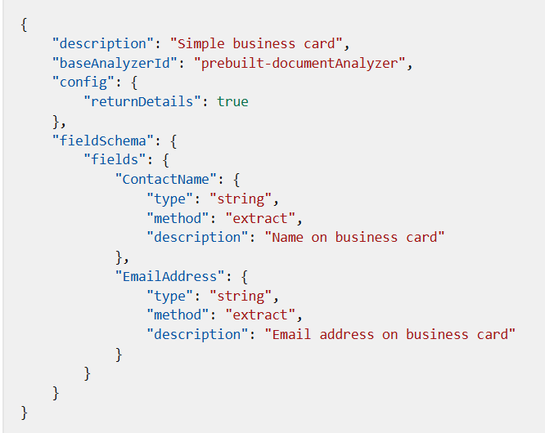
This example of a custom analyzer schema is based on the pre-built document analyzer, and describes two fields that you would expect to find on a business card: ContactName and EmailAddress. Both fields are defined as string data types, and are expected to be extracted from a document (in other words, the string values are expected to exist in the document so they can be "read"; rather than being fields that can be generated by inferring information about the document).

Using the REST API to create an analyzer
- With your analyzer definition in place, you can use the REST API to submit it to Azure AI Content Understanding to be created. The JSON data is submitted as a PUT request to the endpoint with the API key in the request header to start the analyzer creation operation.
- The response from the PUT request includes a Operation-Location in the header, which provides a callback URL that you can use to check on the status of the request by submitting a GET request.
- You can use any HTTP-capable client tool or language to submit the request.

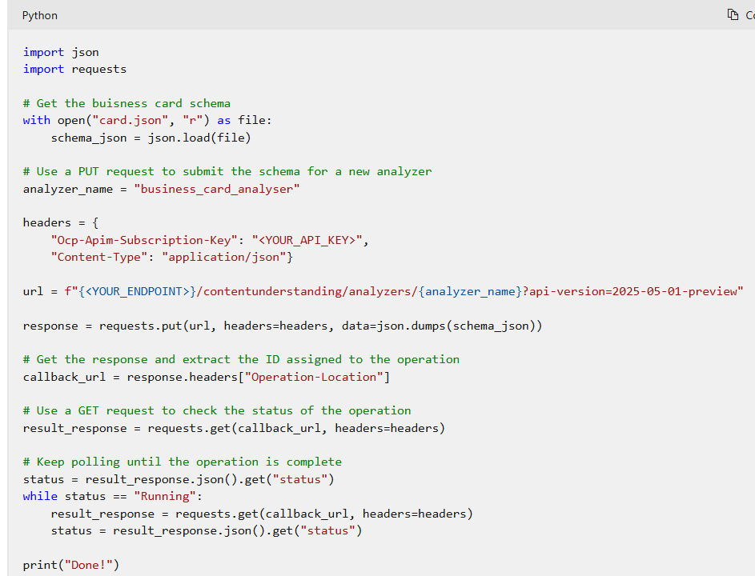

Analyze content
- To analyze the contents of a file, you can use the Azure AI Content Understanding REST API to submit it to the endpoint using a POST request. You can specify the content as a URL (for a file hosted in an Internet-accessible location) or as the binary contents of the file (for example, a .pdf document, a .png image, an .mp3 audio file, or an .mp4 video file). The request header must include the API key, and the endpoint address for the analyze request includes the analyzer to be used.
- As with the request to create an analyzer, the analyze request starts an asynchronous operation. The POST request returns a unique operation ID, which you can then use in a GET request to check the status of the analysis operation.
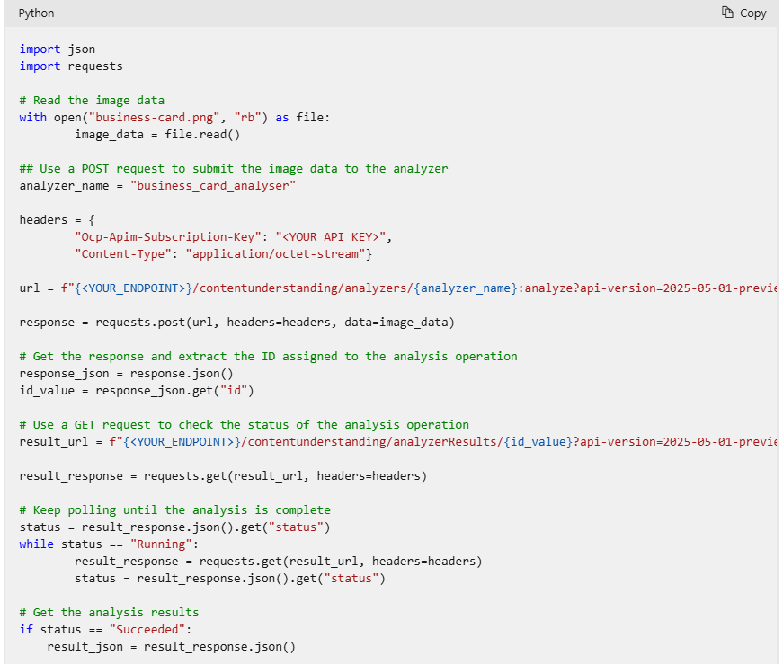

5.3 - Use prebuilt Document intelligence models
Understand prebuilt models
Prebuilt models in Azure AI Document Intelligence enable you to extract data from common forms and documents without training your own models.
What are prebuilt models?
Microsoft trains these models on a large corpus of examples, you can expect them to provide accurate and reliable results when dealing with their intended forms.
Several of the prebuilt models are trained on specific form types:
- Invoice model. Extracts common fields and their values from invoices.
- Receipt model. Extracts common fields and their values from receipts.
- US Tax model. Unified US tax model that can extract from forms such as W-2, 1098, 1099, and 1040.
- ID document model. Extracts common fields and their values from US drivers' licenses, European Union IDs and drivers license, and international passports.
- Business card model. Extracts common fields and their values from business cards.
- Health insurance card model. Extracts common fields and their values from health insurance cards.
- Marriage certificate. Extracts information from marriage certificates.
- Credit/Debit card model. Extracts common information from bank cards.
- Mortgage documents. Extracts information from mortgage closing disclosure, Uniform Residential Loan Application (Form 1003), Appraisal (Form 1004), Validation of Employment (Form 1005), and Uniform Underwriting and Transmittal Summary (Form 1008).
- Bank statement model. Extracts account information including beginning and ending balances, transaction details from bank statements.
- Pay Stub model. Extracts wages, hours, deductions, net pay, and other common pay stub fields.
- Check model. Extracts payee, amount, date, and other relevant information from checks.
The other models are designed to extract values from documents with less specific structures:
- Read model. Extracts text and languages from documents.
- General document model. Extract text, keys, values, entities, and selection marks from documents.
- Layout model. Extracts text and structure information from documents.
Features of prebuilt models
The prebuilt models are designed to extract different types of data from the documents and forms users submit. To select the right model for your requirements, you must understand these features:
- Text extraction. All the prebuilt models extract lines of text and words from hand-written and printed text.
- Key-value pairs. Many models extract spans of text within a document that identify a label or key and its response or value as key-values pairs. For example, a typical key might be Weight and its value might be 31 kg.
- Entities. Text that includes common, more complex data structures can be extracted as entities. Entity types include people, locations, and dates.
- Selection marks. Some models extract spans of text that indicate a choice as selection marks. These marks include radio buttons and check boxes.
- Tables. Many models can extract tables in scanned forms included the data contained in cells, the numbers of columns and rows, and column and row headings. Tables with merged cells are supported.
- Fields. Models trained for a specific form type identify the values of a fixed set of fields. For example, the Invoice model includes CustomerName and InvoiceTotal fields.

Also consider that prebuilt models are designed for and trained on generic document and form types. If you have an industry-specific or unique form type that you use often, you might be able to obtain more reliable and predictable results by using a custom model. However, custom models take time to develop because you must invest the time and resources to train them on example forms before you can use it. The larger the number of example forms you provide for training, the better the model is at predicting form content accurately.

Try out prebuilt models with Azure AI Document Intelligence Studio
Azure AI Document Intelligence is designed as a web service you can call using code in your custom applications. However, it's often helpful to explore the models and how they behave with your forms visually. You can perform such experiments by using Azure AI Document Intelligence Studio https://documentintelligence.ai.azure.com and use the experience to help design and write your code.

Input requirements
The prebuilt models are flexible but you can help them to return accurate and helpful results by submitting one clear photo or high-quality scan for each document.
You must also comply with these requirements when you submit a form for analysis:
- The file must be in JPEG, PNG, BMP, TIFF, or PDF format. Additionally, the Read model can accept Microsoft Office files.
- The file must be smaller than 500 MB for the standard tier, and 4 MB for the free tier.
- Images must have dimensions between 50 x 50 pixels and 10,000 x 10,000 pixels.
- PDF documents must have dimensions less than 17 x 17 inches or A3 paper size.
- PDF documents must not be protected with a password.
If you can, submit text-embedded PDF files because they eliminate errors in character recognition.
PDF and TIFF files can have any number of pages but, in the standard tier, only the first 2,000 pages are analyzed. In the free tier, only the first two pages are analyzed.

Calling prebuilt models by using APIs
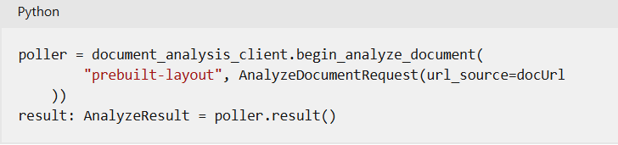

Use the General Document, Read, and Layout models
If you want to extract text, languages, and other information from documents with unpredictable structures, you can use the read, general document, or layout models.
Using the read model
- The Azure AI Document Intelligence read model extracts printed and handwritten text from documents and images. It's used to provide text extraction in all the other prebuilt models.
- The read model can also detect the language that a line of text is written in and classify whether it's handwritten or printed text.
- The read model supports more languages for printed text than handwritten text. Check the documentation to see the current list of supported languages.
- For multi-page PDF or TIFF files, you can use the pages parameter in your request to fix a page range for the analysis.
- The read model is ideal if you want to extract words and lines from documents with no fixed or predictable structure.
Using the layout model
As well as extracting text, the layout model returns selection marks and tables from the input image or PDF file. It's a good model to use when you need rich information about the structure of a document.
When you digitize a document, it can be at an odd angle. Tables can have complicated structures with or without headers, cells that span columns or rows, and incomplete columns or rows. The layout model can handle all of these difficulties to extract the complete document structure.
For example, each table cell is extracted with:
- Its content text.
- The size and position of its bounding box.
- If it's part of a header column.
- Indexes to indicate its row and column position in the table.
Selection marks are extracted with their bounding box, a confidence indicator, and whether they're selected or not.

Using the general document model
The general document model extends the functionality of the read model by adding the detection of key-value pairs, entities, selection marks, and tables. The model can extract these values from structured, semi-structured, and unstructured documents.
The general document model is the only prebuilt model to support entity extraction. It can recognize entities such as people, organizations, and dates and it runs against the whole document, not just key-value pairs. This approach ensures that, when structural complexity has prevented the model extracting a key-value pair, an entity can be extracted instead. Remember, however, that sometimes a single piece of text might return both a key-value pair and an entity.
The types of entities you can detect include:
- Person. The name of a person.
- PersonType. A job title or role.
- Location. Buildings, geographical features, geopolitical entities.
- Organization. Companies, government bodies, sports clubs, musical bands, and other groups.
- Event. Social gatherings, historical events, anniversaries.
- Product. Objects bought and sold.
- Skill. A capability belonging to a person.
- Address. Mailing address for a physical location.
- Phone number. Dialing codes and numbers for mobile phones and landlines.
- Email. Email addresses.
- URL. Webpage addresses.
- IP Address. Network addresses for computer hardware.
- DateTime. Calendar dates and times of day.
- Quantity. Numerical measurements with their units.

Use financial, ID, and tax models
Azure AI Document Intelligence includes some prebuilt models that are trained on common form types. You can use these models to obtain the values of common fields from invoices, receipts, business cards, and more.

Using the invoice model
Your business both issues invoices and receives them from partner organization. There might be many different formats on paper or in digitized forms and some will have been scanned poorly at odd angles or from creased paper.
The invoice model in Azure AI Document Intelligence can handle these challenges and uses the features of the read model to extract text from invoice scans. In addition, it extracts specific fields that are commonly used on invoices including:
- Customer name and reference ID
- Purchase order number
- Invoice and due dates
- Details about the vendor, such as name, tax ID, physical address.
- Similar details about the customer.
- Billing and shipping addresses.
- Amounts such as total tax, invoice total, and amount due.
Invoices also feature lines, usually in a table, each of which is one purchased item. For each line, the invoice model identifies details including:
- The description and product code of the product or service invoiced.
- Amounts such as the unit price, the quantity of items, the tax incurred, and the line total.
Using the business card model
Business cards are a popular way to exchange contact information quickly and often include branding, unusual fonts, and graphic design elements. Fields that the business card model can extract include:
- First and last names.
- Postal addresses.
- Email and website addresses.
- Various telephone numbers.

Using the receipt model
Receipts have similar fields and structures to invoices, but they record amounts paid instead of amounts charged. Azure AI Document Intelligence faces the same challenges of poor scanning or digitization but can reliably identify fields including:
- Merchant details such a name, phone number, and address.
- Amounts such as receipt total, tax, and tip.
- The date and time of the transaction.
As for invoices, receipts often include a table of items, each of which is a product or service purchased. For each of these lines, the model recognizes:
- The name of the item.
- The quantity of the item purchased.
- The unit price of the item.
- The total price for that quantity.
In Azure AI Document Intelligence v3.0 and later, the receipt model supports single-page hotel receipt processing. If a receipt is classified as a hotel receipt, the model extracts extra relevant fields such as arrival and departure dates.

Using the ID document model
The ID document model is trained to analyze two types of identity document:
- United States drivers licenses.
- International passports.
Only the biographical pages of passports can be analyzed. Visas and other travel documents are not supported.
The ID document model can extract fields including:
- First and last names.
- Personal information such as sex, date of birth, and nationality.
- The country and region where the document was issued.
- Unique numbers such as the document number and machine readable zone.
- Endorsements, restrictions, and vehicle classifications.

5.4 - Extract data from forms with Azure Document intelligence
What is Azure Document Intelligence?
- Azure Document Intelligence is one of many Azure AI Services, cloud-based artificial intelligence (AI) services with REST APIs and client library SDKs that can be used to build intelligence into your applications.
- Azure Document Intelligence uses Optical Character Recognition (OCR) capabilities and deep learning models to extract text, key-value pairs, selection marks, and tables from documents.
- OCR captures document structure by creating bounding boxes around detected objects in an image. The locations of the bounding boxes are recorded as coordinates in relation to the rest of the page. Azure Document Intelligence services return bounding box data and other information in a structured form with the relationships from the original file.

Azure Document Intelligence service components
Azure Document Intelligence is composed of the following services:
- Document analysis models: which take an input of JPEG, PNG, PDF, and TIFF files and return a JSON file with the location of text in bounding boxes, text content, tables, selection marks (also known as checkboxes or radio buttons), and document structure.
- Prebuilt models: which detect and extract information from document images and return the extracted data in a structured JSON output. Azure Document Intelligence currently supports prebuilt models for several forms, including:
  - W-2 forms
  - Invoices
  - Receipts
  - ID documents
  - Business cards
- Custom models: custom models extract data from forms specific to your business. Custom models can be trained through the Azure Document Intelligence Studio.

Get started with Azure Document Intelligence
To start a project with Azure Document Intelligence services, you need an Azure resource and selection of form files for data extraction.
Subscribe to a resource
You can access Azure Document Intelligence services via:
  - An Azure AI Service resource: a multi-service subscription key (used across multiple Azure AI Services)
  - An Azure Document Intelligence resource: a single-service subscription key (used only with a specific Azure AI Service)
Azure Document Intelligence works on input documents that meet these requirements:
- Format must be JPG, PNG, BMP, PDF (text or scanned), or TIFF.
- The file size must be less than 500 MB for paid (S0) tier and 4 MB for free (F0) tier.
- Image dimensions must be between 50 x 50 pixels and 10,000 x 10,000 pixels.
- The total size of the training data set must be 500 pages or less.

Decide what component of Azure Document Intelligence to use
After you collect your files, decide what you need to accomplish.
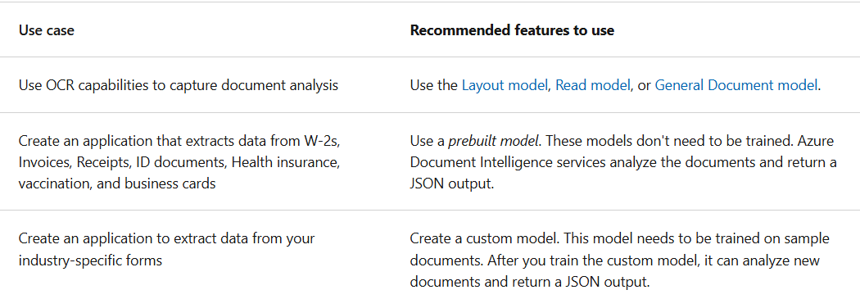

Train custom models
Azure's Azure Document Intelligence service supports supervised machine learning. You can train custom models and create composite models with form documents and JSON documents that contain labeled fields.
To train a custom model:
- Store sample forms in an Azure blob container, along with JSON files containing layout and label field information.
- Generate a shared access security (SAS) URL for the container.
- Use the Build model REST API function (or equivalent SDK method).
- Use the Get model REST API function (or equivalent SDK method) to get the trained model ID.
OR
- Use the Azure Document Intelligence Studio to label and train. There are two types of underlying models for custom forms custom template models or custom neural models.
  - Custom template models accurately extract labeled key-value pairs, selection marks, tables, regions, and signatures from documents. Training only takes a few minutes, and more than 100 languages are supported.
  - Custom neural models are deep learned models that combine layout and language features to accurately extract labeled fields from documents.This model is best for semi-structured or unstructured documents.

Use Azure Document Intelligence models
Using the API
To extract form data using a custom model, use the analyze document function of either a supported SDK, or the REST API, while supplying model ID (generated during model training). This function starts the form analysis. which you can then request the result to get the analysis.
A successful JSON response contains analyzeResult that contains the content extracted and an array of pages containing information about the document content.
Understanding confidence scores
If the confidence values of the analyzeResult are low, try to improve the quality of your input documents.
You want to make sure that the form you're analyzing has a similar appearance to forms in the training set if the confidence values are low. If the form appearance varies, consider training more than one model, with each model focused on one form format.
Depending on the use case, you might find that a confidence score of 80% or higher is acceptable for a low-risk application. For more sensitive cases, like reading medical records or billing statements, a score of 100% is recommended.

5.5 - Create a knowledge mining solution with Azure AI Search
What is Azure AI Search?
Azure AI Search provides a cloud-based solution for indexing and querying a wide range of data sources, and creating comprehensive and high-scale search solutions. It provides the infrastructure and tools to create search solutions that extract data from structured, semi-structured, and non-structured documents and other data sources.
  - With Azure AI Search, you can:
  - Index documents and data from a range of sources.
  - Use AI skills to enrich index data.
  - Store extracted insights in a knowledge store for analysis and integration.
Azure AI Search indexes contain insights extracted from your data; which can include text inferred or read using OCR from images, entities and key phrases detection through text analytics, and other derived information based on AI skills that are integrated into the indexing process.
Extract data with an indexer
- At the heart of Azure AI Search solutions is the creation of an index An index contains your searchable content and is created and updated, unsurprisingly, by an indexer.
- The indexing process starts with a data source: the storage location of your original data artifacts; for example, an Azure blob store container full of documents, a database, or some other store.
- The Indexer automates the extraction and indexing of data fields through an enrichment pipeline, in which it applies document cracking to extract the contents of the source documents and applies incremental steps to create a hierarchical (JSON-based) document with the required fields for the index definition.
- The result is a populated index, which can be queried to return specified fields from documents that match the query criteria.
How documents are constructed during indexing
The indexing process works by creating a document for each indexed entity. During indexing, an enrichment pipeline iteratively builds the documents that combine metadata from the data source with enriched fields extracted or generated by skills. You can think of each indexed document as a JSON structure, which initially consists of a document with the index fields you have mapped to fields extracted directly from the source data

Enrich extracted data with AI skills
The enrichment pipeline that is orchestrated by an indexer uses a skillset of AI skills to create AI-enriched fields. The indexer applies each skill in order, refining the index document at each step.
Built-in skills
Azure AI Search provides a collection of built-in skills that you can include in a skillset for your indexer. Built-in skills include functionality from Azure AI services such as Azure AI Vision and Azure AI Language, enabling you to apply enrichments such as:
- Detecting the language that text is written in.
- Detecting and extracting places, locations, and other entities in the text.
- Determining and extracting key phrases within a body of text.
- Translating text.
To use the built-in skills, your indexer must have access to an Azure AI services resource. You can use a restricted Azure AI search resource that is included in Azure AI Search (and which is limited to indexing 20 or fewer documents) or you can attach an Azure AI services resource in your Azure subscription (which must be in the same region as your Azure AI Search resource).
Custom skills
You can further extend the enrichment capabilities of your index by creating custom skills. As the name suggests, custom skills perform custom logic on input data from your index document to return new field values that can be incorporated into the index. Often, custom skills are "wrappers" around services that are specifically designed to extract data from documents.

Search an index
The index is the searchable result of the indexing process. It consists of a collection of JSON documents, with fields that contain the values extracted during indexing. Client applications can query the index to retrieve, filter, and sort information.
Each index field can be configured with the following attributes:
- key: Fields that define a unique key for index records.
- searchable: Fields that can be queried using full-text search.
- filterable: Fields that can be included in filter expressions to return only documents that match specified constraints.
- sortable: Fields that can be used to order the results.
- facetable: Fields that can be used to determine values for facets (user interface elements used to filter the results based on a list of known field values).
- retrievable: Fields that can be included in search results (by default, all fields are retrievable unless this attribute is explicitly removed).

Persist extracted information in a knowledge store
While the index might be considered the primary output from an indexing process, the enriched data it contains might also be useful in other ways. For example:
- Since the index is essentially a collection of JSON objects, each representing an indexed record, it might be useful to export the objects as JSON files for integration into a data orchestration process for extract, transform, and load (ETL) operations.
- You may want to normalize the index records into a relational schema of tables for analysis and reporting.
- Having extracted embedded images from documents during the indexing process, you might want to save those images as files.
Azure AI Search supports these scenarios by enabling you to define a knowledge store in the skillset that encapsulates your enrichment pipeline. The knowledge store consists of projections of the enriched data, which can be JSON objects, tables, or image files. When an indexer runs the pipeline to create or update an index, the projections are generated and persisted in the knowledge store.

